EQ – How can we use 1 angle and 1 side in a right triangle to solve for the unknowns.

Trigonometry: A definition
Trigonometry is the study of angles and the edges that they are made up from. It forms a very important part of a number of professional fields including science, engineering and other areas of applied maths. However, trigonometry is also used often by builders, carpenters, surveyors, architects, town planners and many other professions.

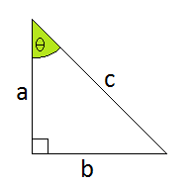
Right Angled Triangle

Trigonometric Ratios
Trig
Ratios
A ratio is a statement of a mathematical relationship comparing two quantities, often represented as a fraction. If we consider an angle (theta) θ in a right angled triangle, we can construct various ratios to compare the lengths of the sides. Special relationships that exist in right angled triangles are called trigonometric ratios.
We have seen that there is a definite relationship between the angles in a right angled triangle and the ratio of sides. We can use these trigonometric ratios to find unknown angles and sides of a triangle.
There are 3 basic trigonometric ratios that relate sides and angles together. They have the special names of tangent, sine and cosine. The names of the relationships date back to 499AD, with ties to Latin and Sanskrit. Actually the word sine is thought to be derived from a translation gone wrong! Regardless the names for these relationships have stuck.
We often shorten the names tangent, sine and cosine to tan, sin and cos respectively.
Trigonometric ratios
$\sin{θ=\frac{opposite side}{Hypotenuse}} or=\frac{opp}{hypot}$

From the angle θ
c is the hypotenuse
a is the adjacent side (alongside)
b is the opposite side
opp
adj
$\cos{θ=\frac{adjacent side}{Hypotenuse}} or=\frac{adj}{hypot}$
$\tan{θ=\frac{opposite side}{adjacent side}} or=\frac{opp}{adj}$

Here is a picture of the above relationships, and for some people the mnemonic of SOHCAHTOA at the bottom is helpful to remember the sides that apply to the different ratios of sine, cosine and tangent.
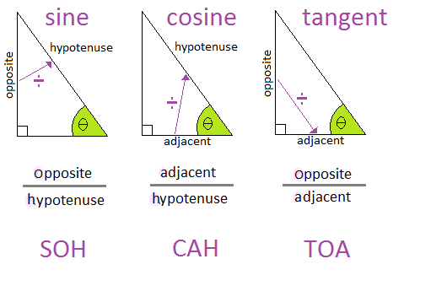
Examples: For each of the following triangles write a ratio (in simplified form – if possible) for sinα, cosα and tanα.
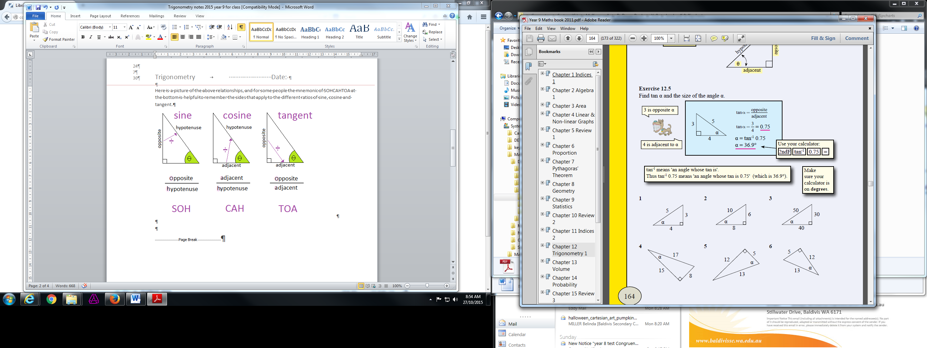

1. $sinα=\frac{opp}{hyp}$
$sinα=\frac{3}{5}$
$$cosα=\frac{adj}{hyp}$$
$$cosα=\frac{4}{5}$$
$$tanα=\frac{opp}{adj}$$
$$cosα=\frac{3}{4}$$
Now try exercise 3E pages 156 – 158 Questions 3 - 12
5. $sinα=\frac{opp}{hyp}$
$sinα=\frac{12}{13}$
$$cosα=\frac{adj}{hyp}$$
$$cosα=\frac{5}{13}$$
$$tanα=\frac{opp}{adj}$$
$cosα=\frac{12}{5}$ Leave as an improper fraction

Finding Side lengths
If we know 2 sides and want to find the third, we would use Pythagorean formula
Side
Lengths
Pythagoras
a²+b²=c²
If we know 1 side length and an angle, we would use one of the trigonometric ratios.
The most common mistake is when the wrong ratio is used. We have to remember the ratios and the sides that apply to those ratios. For most students the mnemonic SOHCAHTOA can be a great help.

Examples
Eg 1. In the triangle on the right find the value of x.
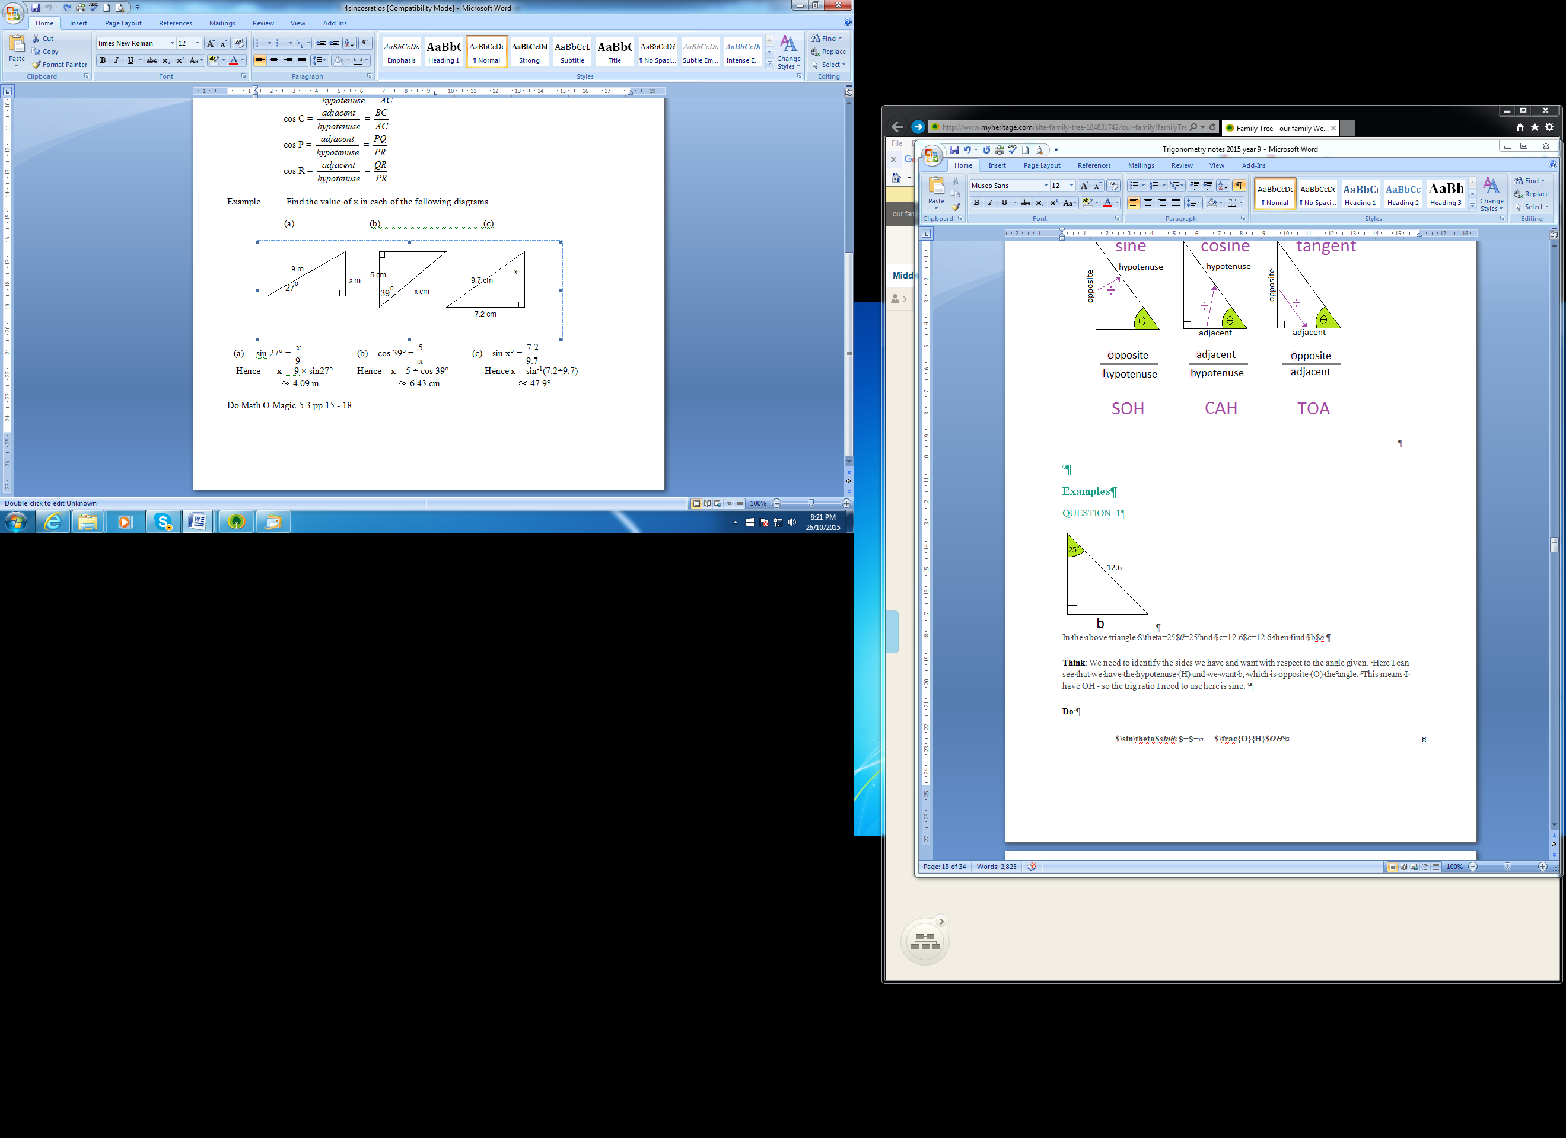
Think: We need to identify the sides we have and want with respect to the angle given. Here I can see that we have the hypotenuse (Hyp) and we want x, which is opposite (Opp) the angle. This means I have Opp & Hyp - so the trig ratio I need to use here is sine.

$\sin{θ=\frac{opp}{hyp}}$
$sin27°=\frac{x}{9}$ put what you know into the equation
$9 × sin27°=x$ cross multiply the 9
$x=4.09m$ Solve for x

Eg 2. In the triangle on the right find the value of x.
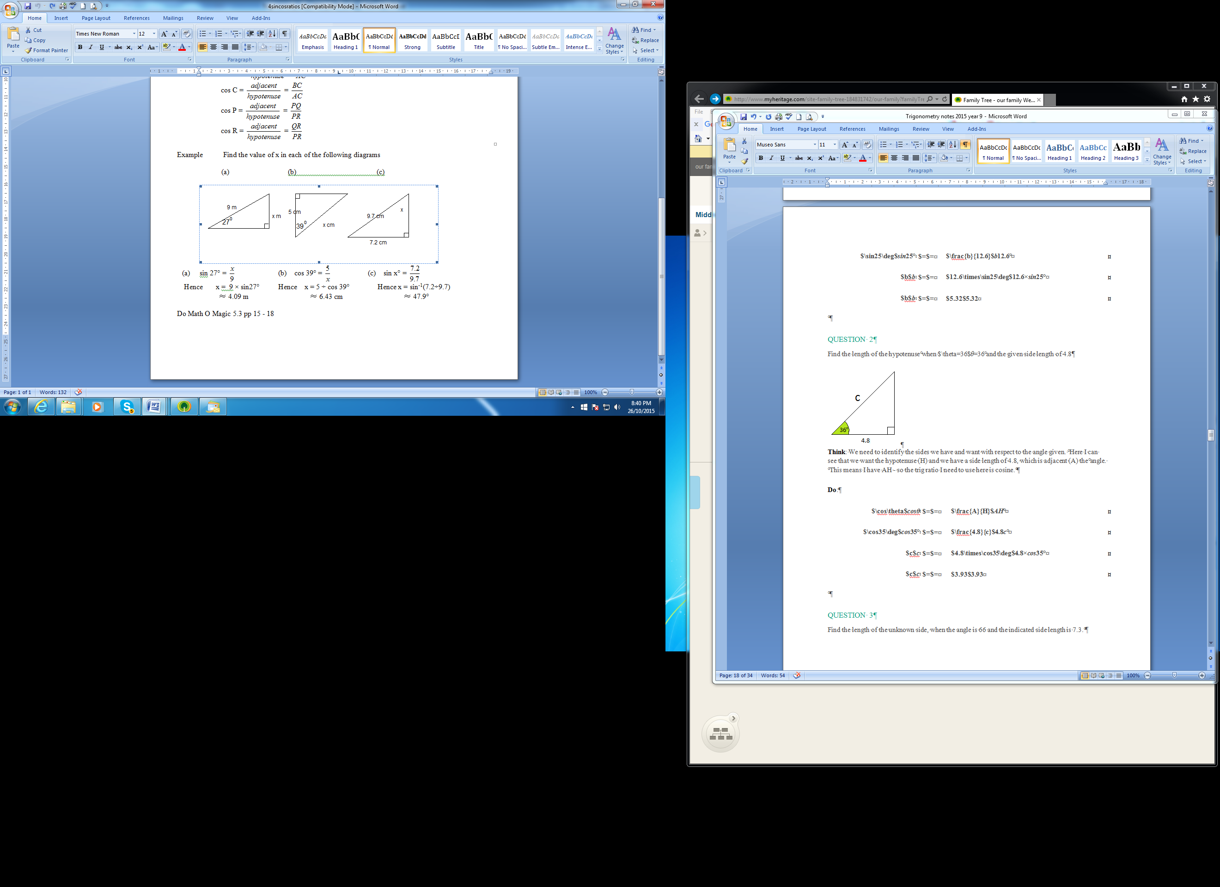

Think: Again we need to identify the sides we have and want with respect to the angle given. Here I can see that we want the hypotenuse (Hyp) and we have a side length of 5cm, which is adjacent (Adj) the angle. This means I have Adj & Hyp - so the trig ratio I need to use here is cosine.

$\cos{θ=\frac{adj}{hyp}}$
$cos39°=\frac{5}{x}$ put what you know into the equation
$x=\frac{5}{cos39°}$ cross multiply the x and the cos39°
$x=6.43cm$ Solve for x

Eg 3. In the triangle on the right find the value of x.

Think: Again we need to identify the sides we have and want with respect to the angle given. Here I can see that we want the adjacent side (Adj) and we have a side length of 67mm, which is opposite (Opp) the angle. This means I have Opp & Adj - so the trig ratio I need to use here is tangent.

$\tan{θ=\frac{opp}{adj}}$
$tan22°=\frac{67}{x}$ put what you know into the equation
$x=\frac{67}{tan22°}$ cross multiply the x and the tan22°
$x=165.8mm$ Solve for x

Some more to have a go at solving for x.
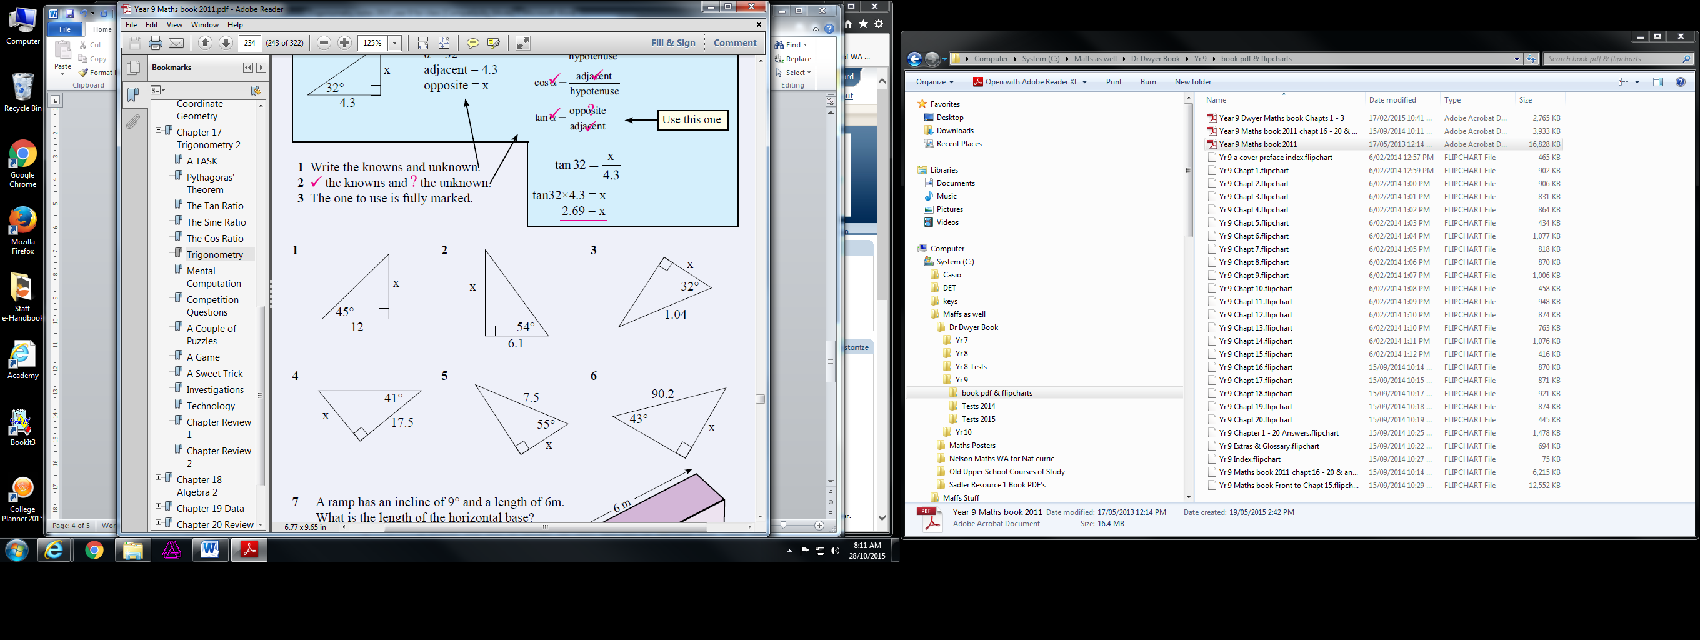
Now try exercise 3F pages 161 – 163 Questions 3 - 11

and exercise 3G pages 166 – 167 Questions 2 - 9

Finding Unknown Angles
Finding Angles
The trigonometric ratios are,

We have used trigonometric ratios to find the lengths of sides now we can also use the trigonometric ratios to find the size of unknown angles. To do this we need any 2 of the side lengths.

To Find the size of an unknown angle:
- Firstly sketch a small diagram of the triangle you are using (a picture)
- label the sides as O, A or H with respect to the position of the angle you want to find
- identify the appropriate trigonometric ratio that applies [either sine (sin), cosine (cos) or tangent (tan)]
- using algebra, solve the equation for the angle, (write the rule, fill in what you know, then solve using inverse operations $\sin^{-1}{},\cos^{-1}{},\tan^{-1}{}$)
- reflect and check (do a quick check on your calculator to confirm your answer is correct)

Examples
Eg 1 Find angle θ to 2dp.
From the angle we are trying to find here
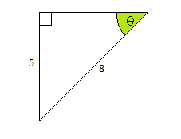
$$\sin{θ}= \frac{Opp}{Hyp}$$
$$θ= \sin^{-1}{(\frac{Opp}{Hyp}})$$
$$θ= \sin^{-1}{(\frac{5}{8}})$$
$$θ=38.68°$$
$$\sin{θ}= \frac{Opp}{Hyp}$$
$$\sin{θ}= \frac{5}{8}$$
$$θ= \sin^{-1}{(\frac{5}{8}})$$
$$θ=38.68°$$
With Opp and Hyp we need to use the sin function
This is the Opposite side (Opp)
This is the Hypotenuse (Hyp)

or

Eg 2 Find angle θ to 2dp.
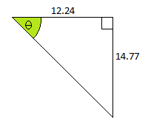
$$\tan{θ}= \frac{Opp}{Adj}$$
$$\tan{θ}= \frac{14.77}{12.24}$$
$$θ= \tan^{-1}{(\frac{14.77}{12.24}})$$
$$θ=50.35°$$
From the angle θ we have an Opp and Adj therefore we are looking for the Tan of the angle.
$$\tan{θ}= \frac{Opp}{Adj}$$
$$θ=\tan^{-1}{(\frac{Opp}{Adj}})$$
$$θ= \tan^{-1}{(\frac{14.77}{12.24}})$$
$$θ=50.35°$$

or

Eg 3 Find angles x, y & z to 2dp.
Firstly let’s find x
$$\tan{x}= \frac{Opp}{Adj}$$
$$x=\tan^{-1}{(\frac{Opp}{Adj}})$$
$$x= \tan^{-1}{(\frac{15}{30}})$$
$$x=26.57°$$
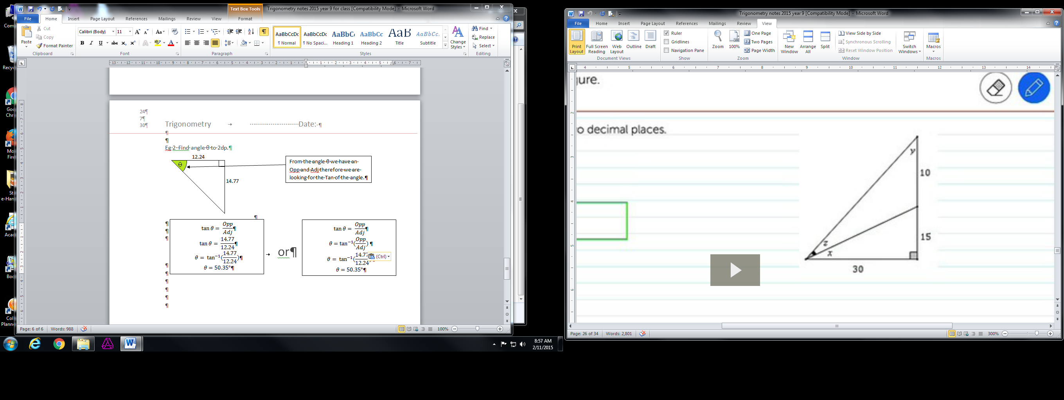

Now let’s find y – Note the adjacent side to y is 15 + 10 = 25
$$\tan{y}= \frac{Opp}{Adj}$$
$$y=\tan^{-1}{(\frac{Opp}{Adj}})$$
$$y= \tan^{-1}{(\frac{30}{25}})$$
$$y=50.19°$$

Finding z: x + z = (90 º – 50.19º)
26.57º + z = 39.81º
Z = 39.81º - 26.57º
Z = 13.24º
∴ x = 26.57º, y = 50.19º & z = 13.24º
Now try exercise 3H pages 170 – 171 Questions 2 - 16

Mixing it up – Applying Pythagoras and Trigonometry
Using Trig and Pythagoras

So far we have found unknown side lengths using Pythagoras' theorem and then looked at 3 special ratios that we can use to find unknown sides or angles in right angled triangles.

Pythagorean Theorem
Pythagorean Theorem states that the square of the hypotenuse (the side opposite the right angle) is equal to the sum of the squares of the other two sides. The theorem can be written algebraically.
a²+b²=c²
where c represents the length of the hypotenuse and a, b are the two shorter sides.
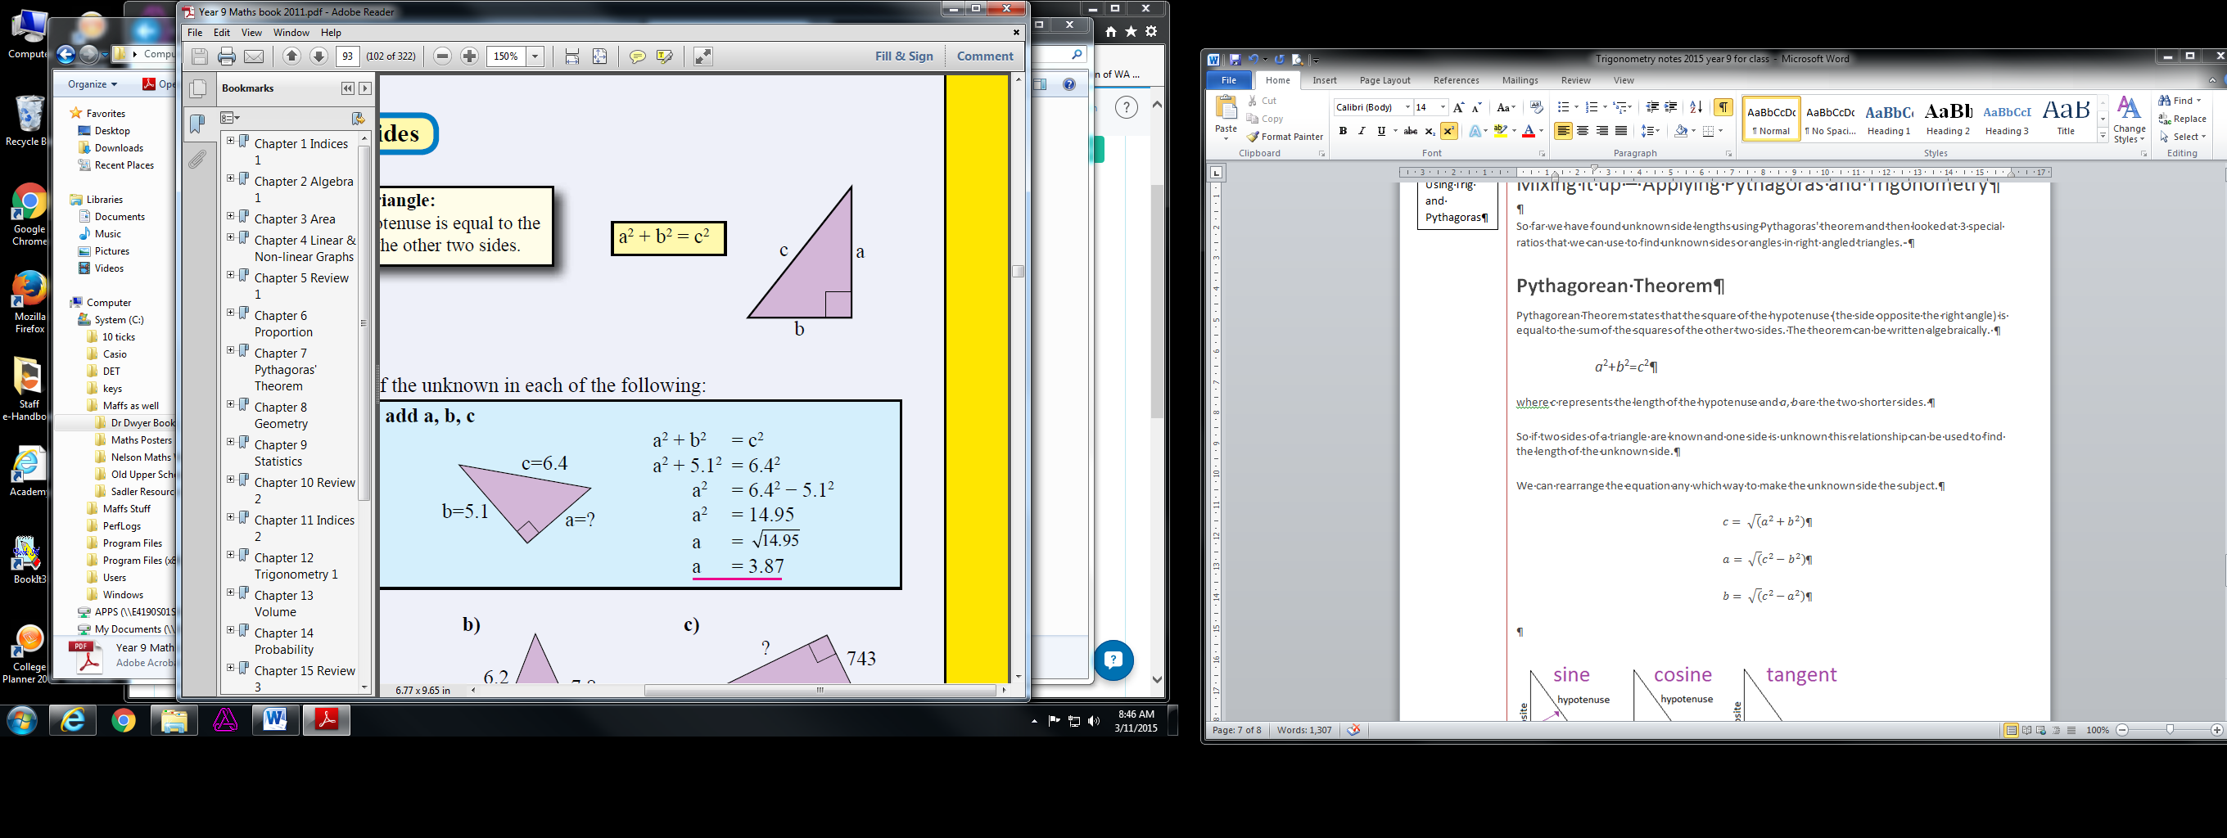

So if two sides of a triangle are known and one side is unknown this relationship can be used to find the length of the unknown side.
We can rearrange the equation any which way to make the unknown side the subject.
$$c= \sqrt{(}a^{2}+b^{2})$$
$$a= \sqrt{(}c^{2}-b^{2})$$
$$b= \sqrt{(}c^{2}-a^{2})$$
And

Problem solving in trigonometry can be in finding unknowns like we have already been doing, using trigonometry in real world applications or in solving geometrical problems like these.

Examples

Eg 1

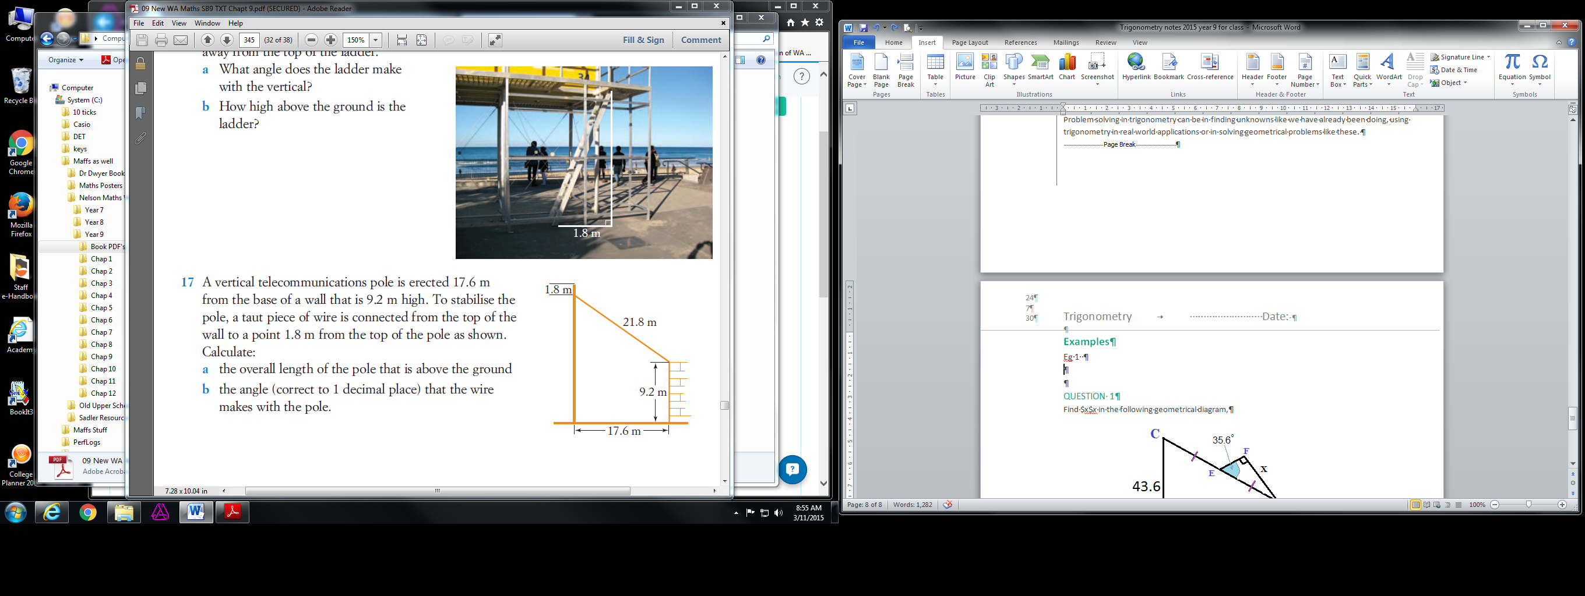

Think: In order to find the answers I will need to add some lines to the diagram.

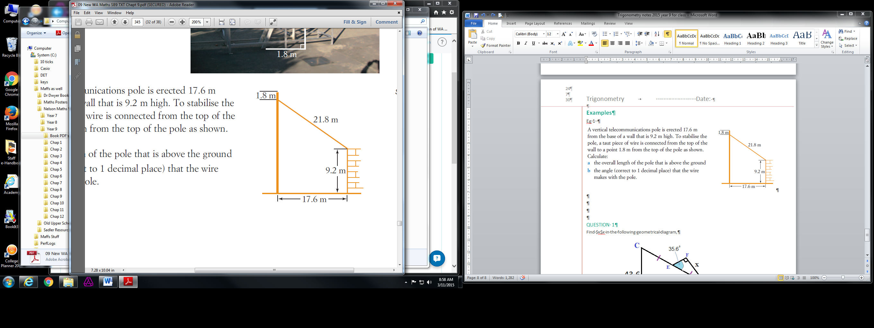
This can be base b
Which is 17.6m
a. overall height of the pole is
9.2m + side a + 1.8m
Side a
a=√(c² – b²)
a=√(21.8² – 17.6²)
a=12.8m
Pole length = 9.2+12.9+1.8
= 23.9m
Looking for the length of this side let’s call it a
Looking for this angle let’s call it θ
This is a right triangle
b. For angle θ we have Opp = 17.6m and Hyp = 21.8m
For this we will use sin
$$\sin{θ}= \frac{Opp}{Hyp}$$
$$θ= \sin^{-1}{(\frac{Opp}{Hyp}})$$
$$θ= \sin^{-1}{(\frac{17.6}{21.8}})$$
$$θ=53.8°$$

∴ the length of the pole is 23.9m and the angle it makes with the wire at the top is 53.8º

Eg 2
Find x in the following geometric diagram to 1dp
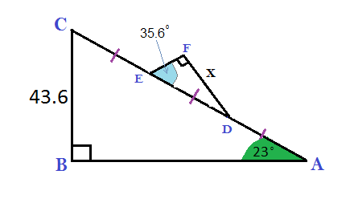
30m

Think: In order to find x, we will need to identify some other measurements along the way. Our problem solving strategy will be
- Find length AC and divide it by 3 to get length ED, we will need to use cos.
- Find x (Opp) using ED (Hyp) and ∠DEF, we will be using sin.
cosθ=adjhyp cos23°=30AC AC=30cos23° AC=32.6mED=32.6/3ED=10.9mcosθ=adjhyp cos23°=30AC AC=30cos23° AC=32.6mED=32.6/3ED=10.9m

$$\sin{θ=\frac{opp}{hyp}}$$
$$sin35.6°=\frac{x}{10.9}$$
$$10.9 × sin35.6°=x$$
$$x=6.3m$$

∴ Length of x is 6.3m to 1dp.

Firstly do the Length of a line and Pythagoras Chapter Review for the test tomorrow.

Now try the exercises given as handouts.
1. The exercise 9.3 Applications of triangles.
2. The Pythagoras and Trig bundle
3. The work that has been set on Mathspace.

